|  |
| --- |
| MINISTRY OF EDUCATION AND SCIENCE OF UKRAINE  NATIONAL TECHNICAL UNIVERSITY  «KHARKIV POLYTECHNIC INSTITUTE»  Department of Software Engineering and Management Information Technologies  List of laboratory reports  discipline « Fundamentals of Operating System »  Executed by: Chukwu Irele omike  Student of group KH-201.8ei.1  Checked by:  Prof. S. L  Gloskakova Anna Alexandrouna  Kharkiv – 2019 |

MINISTRY OF EDUCATION AND SCIENCE OF UKRAINE

NATIONAL TECHNICAL UNIVERSITY

«KHARKIV POLYTECHNIC INSTITUTE»

Department of Software Engineering and Management Information Technologies

Report from lab № 2

discipline « Fundamentals of Operating System »

Kharkiv

2019

**Theme :**

**Introduction to OS Linux.**

**Working with files in UNIX/LINUX.**

**Objective:** introduction to the unix command line , commands to work with the file system and commands for processing file ;

**Scenario: Introduction to UNIX directories:**

This scenario will highlight acquaintance with UNIX commands, studying the file system and base directories, creating a working environment in the user's home directory for all subsequent commands.

Get the name of the current directory using the **pwd** command:

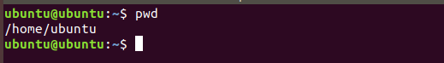

Go to the root directory with the **cd /** command:

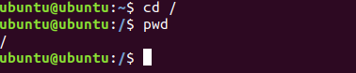

View the contents of the root directory with the **ls** command:

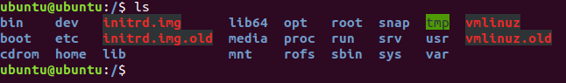

Compare using the "extended" output of the **ls -F** command:

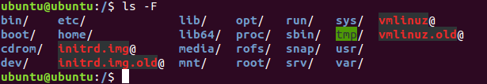

View the contents of the home directory with the **ls ~** command:

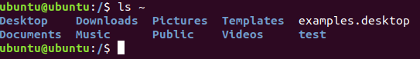

Create a test dire ctor y with the **mkdir test** c ommand:



View the updated content of the home directory **ls**:

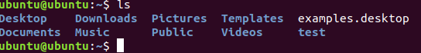

Create a subtest subd irectory in the test dire ctory with t he **mkdir test /subte st** command:



View the contents of the home directory and its subdirectories by using the recursive *–R* key in the ls -R command:

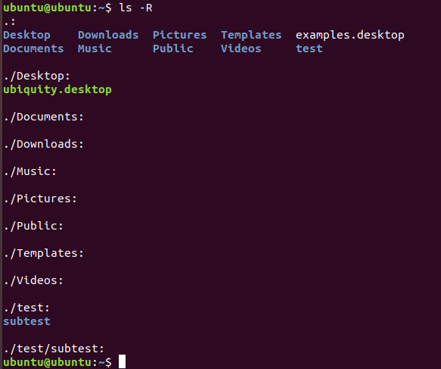

**Scenario: Exploring file types on UNIX**

In this scenario, file types on UNIX are considered: simple files, directories, links. The commands for creating and copying files are being studied. The difference between hard and symbolic links, between copying and transferring a file is shown.

Create an empty file using the touch **f**irst.t**x**t command:

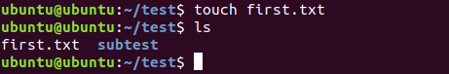

Add a line of text to the end of the file with the command echo "**H**ello, world" **>> f**irst.t**x**t and redirect the output:



View the contents of the file with the command **cat first. txt:**

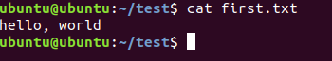

View advanced information about the directory using the *-l* option of the **ls** command. **ls -l test:**

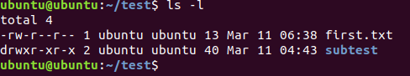

Add the alias of the shell to reduce the size of the command, using the command alias **ls='ls -F -l'**:

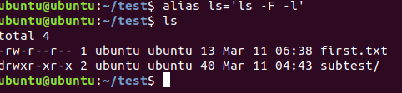

Look deeper into the test directory using the keys *-a* and *-i*. **ls -a –i**

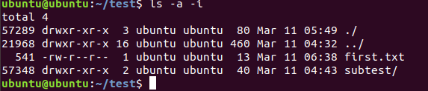

Copy the file using the command **cp first.txt copy1.txt**:

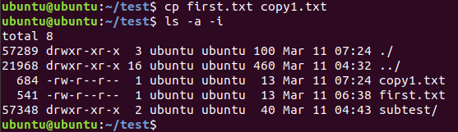

Rename a file using the command mv first.txt orig.txt:

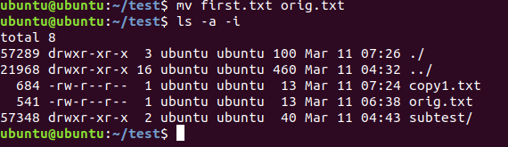

Create a hard link with the command **ln orig.txt copy2.txt**:

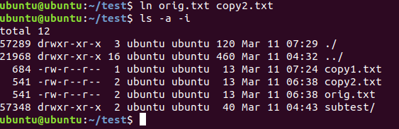

Create a symbolic link with the command **ln -s orig.txt orig.lnk:**

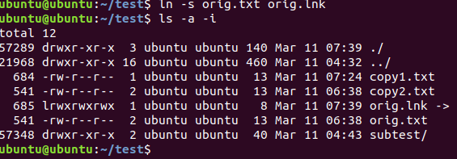

Compare the contents of files by accessing them by name:

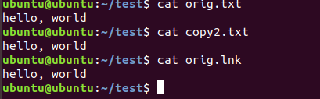

**Scenario: Searching for system logs**

In this scenario, the file and directory search command is examined.

List all files and directories in the current directory, including the contents of the subdirectories with the **find** command:

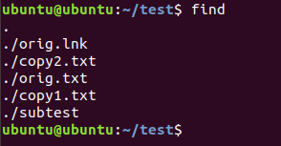

Find all the files and directories in the current directory and its subdirectories that start with "o" using the command **find -name "o*"**:

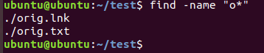

The list of found files can be too large and you can use the Shift-PgUp and Shift-PgDn keys to scroll the terminal. You have seen a lot of "Permission denied" error messages that can be suppressed by redirecting errors as follows: **find /etc - name "o*" 2>/dev/null**

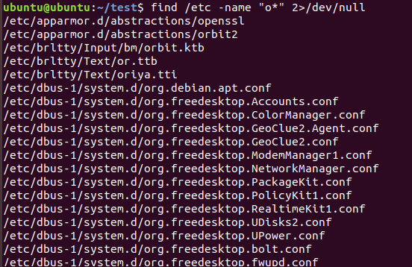

Find all the directories in /etc that start with "o" using the command **find /etc –name "o*" -a -type d 2>/dev/null**:

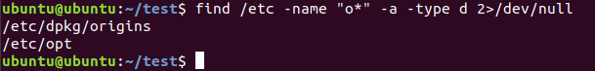

Find all the regular files in the /var directory and its subdirectories ending with "log":

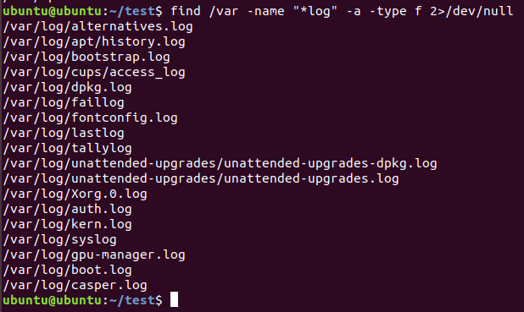

Create the logs directory with the command **mkdir logs**:

C:\Users\irele\AppData\Local\Microsoft\Windows\INetCache\Content.Word\logs.png

Copy the found files to the local directory by using the -exec option of the find command. To do this:

**find /var -name "*log" -a -type f -exec cp {} test/logs/2>/dev/null**

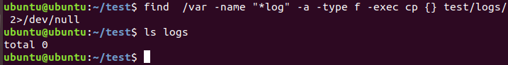

**Scenario: Archiving and de-archiving files and directories**

In this scenario, the command for archiving files and directories is being studied. The command line, the test directory after the last script.

Create an archive named test.tar.gz using compression, containing the test directory with the command **tar -czf test.tar.gz test**:

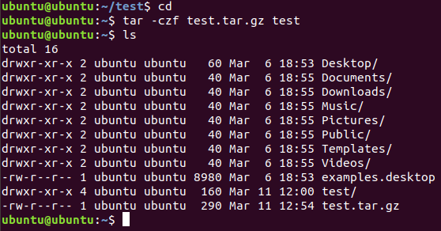

Create a new directory for the contents of the archive with the command **mkdir test2**:



Go to the new directory using the command **cd test2**:



Expand the contents of the archive to the current directory using the command **tar -xzf ../test.tar.gz**:



Make sure that the contents of the unpacked archive coincide with the original directory. Enter the command **ls -l -F**:

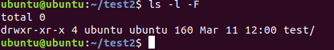

**Scenario: Creating new text files**

In this scenario, commands are examined for creating and modifying text files. Command line.

Enter the command echo "One line":



This command takes a string as an argument and prints it to standard output. Enter the same command, but redirect the output to the second.txt file with ">". Enter the command **echo "One line" > second.txt**:



Add the line "A line" to the end of file second.txt with another redirect echo "A line" >> second.txt:



Output the contents of a file using the command cat second.txt:

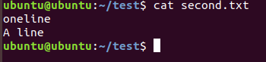

Using the cat command, you can create multi-line files - if you redefine the program output to a file and enter text before pressing Ctrl**-**D (end of input). Introduce the team **cat >multiline.txt** and type the text

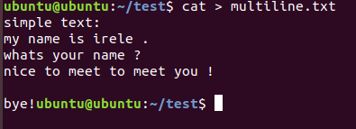

Ensure that the contents of the file are the same as the text entered, including all line feeds. To do this, enter the command **cat multiline.txt**

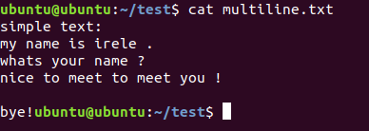

1. The main purpose of the cat command is to combine files whose names are passed as command-line arguments. Merge files with the command **cat orig.txt second.txt multiline.txt > big.txt**:

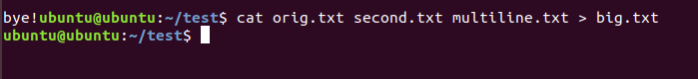

1. Make sure that the new file contains the lines from the listed files using the command **cat big.txt**:

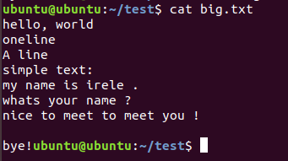

**Conclusion:**

In this laboratory the following was considered :

**Introduction to UNIX directories**

**Exploring file types on UNIX**

**Searching for system logs**

**Archiving and de-archiving files and directories**

**Creating new text files**